**Selecting the S3 bucket you want to empty**

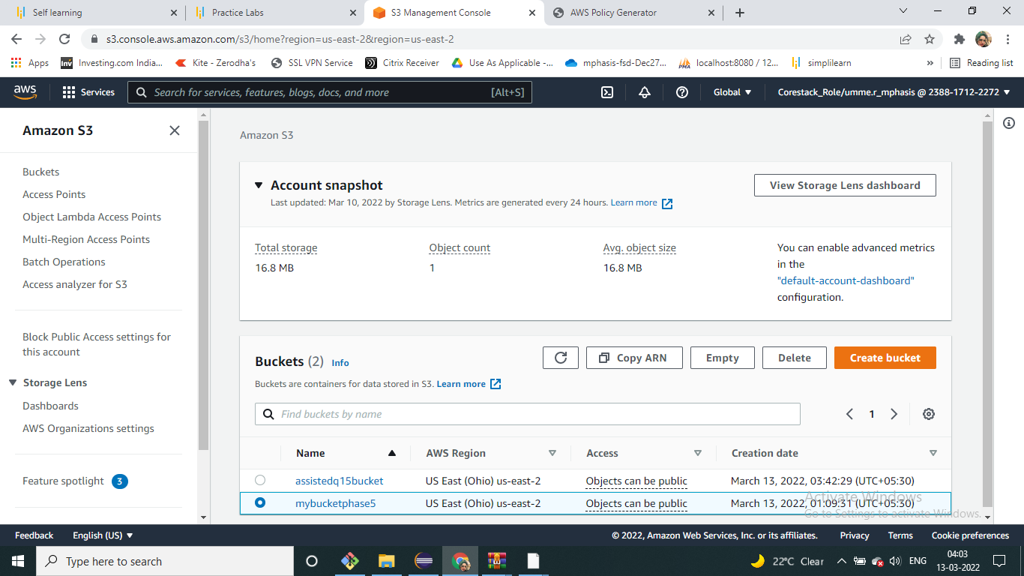

**Verify the content present in the bucket**

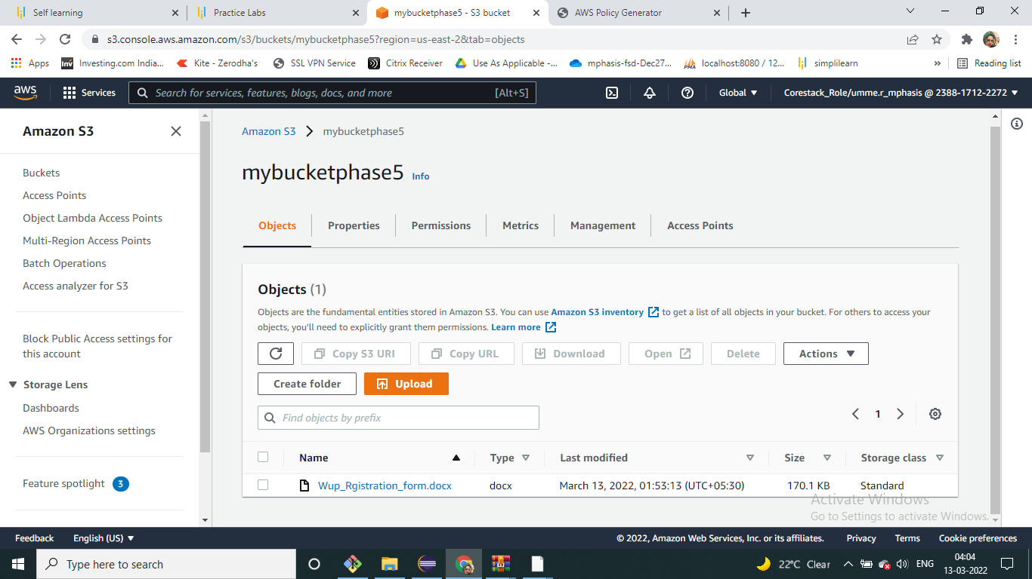

**Empty the bucket**

